BURIED IN DEBT:
HOW EXPLODING STUDENT LOAN DEBT HARMS WASHINGTON’S
STUDENTS, GRADUATES & ECONOMY

College costs continue to rise in Washington.
- For 2013-14, in-state tuition and fees at public four-year colleges and universities in Washington averaged $10,811. That’s up 78 percent since 2004-05. A four-year degree will cost $43,244 in tuition and fees (not counting room and board, books, other living expenses, or expected increases in tuition and fees).
- Tuition and fees at private, nonprofit four-year schools in Washington averaged $34,517 for 2013-14, up 32 percent since 2004-05.¹ A four-year degree will cost $138,068 in tuition and fees alone.

Across the U.S., student loan debt is RISing rapidly.
- Total education debt in the U.S. approached $1.2 trillion in 2013. Outstanding student debt has more than doubled since 2005.
- 38.8 million Americans carried student loan debt in 2012, up 56 percent since 2005. Average debt per borrower reached $24,800 in 2012, up 33 percent since 2005.
- In 2009-2010, outstanding student loan debt surpassed U.S. credit card debt and auto loan debt. Student debt is now the second largest balance of household debt after mortgage debt.³

The average student loan debt for Washington’s Class of 2012 was more than $23,000. Interest payments add thousands more to the cost of repaying these debts.
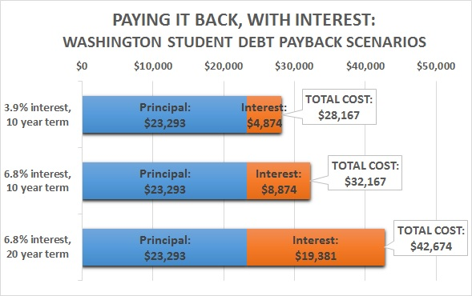
- In Washington, the average student debt for members of the Class of 2012 who graduated with loans was $23,293. With different rates and terms, interest payments add anywhere from nearly $5,000 to almost $20,000 to the total cost of repayment.
- At 3.9 percent interest over a 10 year term, interest payments on a $23,293 loan add almost $5,000 to the total cost of repayment.
- At 6.8 percent interest over 10 years, interest payments add almost $9,000 to the payback cost.
- At 6.8 percent interest over an extended term of 20 years, interest payments add almost $20,000 – close to doubling the total cost of the loan.

Things you could do with $234.72
every month for 10 years…
Put food on the table… | Pay your grocery bill ($203/month for an individual) for 10 years.
Fill the tank… | Fill your gas tank 5 times a month ($47/tank).
Ride in style… | No tank to fill? No problem. Buy a 2014 Ford Fiesta ($224/month for 60 months)… or lease a 2014 Ford Mustang ($226/month).
Get real clean… | Buy a new washer/dryer set ($1,165)… twice a year for 10 years. Kiss the Laundromat goodbye… or start your own.
Grow your family… | Pay for diapers and formula for a baby ($210/month).
Catch some air… | Rack up the frequent flyer miles. Fly to Hawaii… or Iceland… 4 times a year.
Student loan payments limit borrowers’ economic choices.
- Even at a 3.9 percent interest rate, with a 10 year term, Washington’s average student debt load of $23,293 translates to a payment of $234.72 a month… every month for 10 years.
- That’s money going to principal and interest on student loan debt that can’t be spent on other things (see table).

Student loan debt is breaking the bank for millions of borrowers.
- 6.7 million student debt holders are 90+ days delinquent on their loans. This is more than 30 percent of all borrowers who are currently in repayment.
- Credit scores for 25- and 30-year-olds with recent student loan debt have declined since 2008, dipping sharply compared to scores for people the same age who don’t carry student debt.¹⁰

The burden of student loan debt is depressing consumer purchasing power and weakening key sectors of the economy.
- Student debt limits the purchasing power of young people coming out of school and looking to start out on their own. Evidence shows young student debt holders are backing off from buying homes or buying cars.¹⁰ This weakens the housing market and the auto market – two key drivers of the economy.
- The impact of the ballooning student loan balance on purchasing power is not limited to young people. While one-third of student debt in 2012 was held by people under age 30, another third was held by people in their 30s. People in their 40s carried 17 percent, people in their 50s carried 12 percent, and people in their 60s carried 5 percent.¹⁰

www.washingtoncan.org | www.allianceforajustsociety.org

http://trends.collegeboard.org/college-pricing/figures-tables/tuition-and-fees-sector-and-state-over-time
http://www.consumerfinance.gov/newsroom/student-debt-swells-federal-loans-now-top-a-trillion/
http://www.newyorkfed.org/regional/Brown_presentation_GWU_2013Q2.pdf
http://trends.collegeboard.org/student-aid/figures-tables/distribution-outstanding-education-debt-balances
http://projectonstudentdebt.org/state_by_state-sum2013.php
http://jobgap2013.files.wordpress.com/2013/12/wa_2013-job-gap_final.pdf
http://www.ford.com/payments-bridge/
http://www.ajmadison.com/cgi-bin/ajmadison/WET3300XQ.html
http://www.orbitz.com
http://www.newyorkfed.org/regional/Brown_presentation_GWU_2013Q2.pdf

